Capture2 Shortlisted for 2019 SaaS Awards
International Software Awards Program Announces Finalists
San Diego – 30 July 2019 – Capture2, Inc. is a finalist in the 2019 SaaS Awards Program in the category Best SaaS Product for Productivity.
The SaaS Awards program is now in its fourth year of celebrating organizational successes and the software innovations that fuel them.
With awards for excellence and innovation in SaaS, the Software-as-a-Service Awards program accepts entries worldwide, including the US, Canada, Australasia, EMEA and UK.
Categories for the 2019 awards program include Best Data-Driven SaaS Product and Best Enterprise-Level SaaS Product, alongside new categories for Continuous Improvement and Catering and Hospitality.
Christopher Pohle, CEO said: “For Capture2 to be shortlisted in the Best SaaS Product for Productivity category is a significant indicator of our innovation and successes in the global software marketplace.”
SaaS Awards and Cloud Awards organizer Larry Johnson said: “The standard of entries this year was incredibly high, with consistent attention to innovation and most importantly, customer success. The volume of entries warranting consideration of a place on the coveted shortlist was unprecedented.
“In our fourth year promoting SaaS exclusively alongside its sister awards program, the Cloud Awards, we have again seen a wide range of entries from Canada, Europe, Australia and the East joining those from the US. Moreover, again we are seeing such innovation from established blue-chips to agile start-ups. All seek to provide essential productivity tools to their users by leveraging cloud-based software solutions. The judges are set to have a nearly impossible task when selecting the final winners in a few short weeks.”
Final SaaS Awards winners will be announced on Tuesday 27 August 2019 and the program will return in Spring 2020. Over 400 organizations entered, with international entries coming from North America, Canada, Australia, UK, Europe and the Middle East.

Contact details
Capture2
Carsen Zarin Groberg- Director, Marketing
Carsen@capture2.com
(314) 249-9853

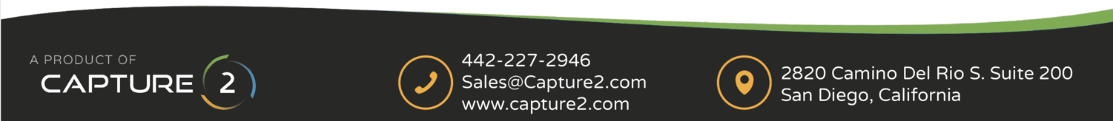
For the SaaS Awards
James Williams – Head of Marketing
https://www.cloud-awards.com/software-as-a-service-awards/
james@cloud-awards.com

